EX. NO. 4 Create a web form that accepts a user’s name andage.
Write a Servlet to process the form data and display it
back on the browser

AIM:
To create a simple web application that includes a form to accept a user&#39;s name and age, and
then use a Servlet to process the submitted data. The Servlet will retrieve the form data,
process it, and display the values back on the browser.

ALGORITHM:
1. Input:
• The user fills out a web form with their name and age and submits it.
2. Form Handling and Servlet Processing:
1. Create the Web Form:
o Create an HTML form with two input fields: one for the user’s name and one
for the user’s age.
o Add a submit button to the form.
o Set the form’s action attribute to the URL of the Servlet and the method to
POST (or GET).
2. Create the Servlet Class:
o Write a Servlet that processes the form data submitted by the user.
o The Servlet will override the doPost() (or doGet() depending on the form
method) to handle form submissions.
o The Servlet will retrieve the name and age parameters from the request
object using request.getParameter(“name”) and request.getParameter(“age”).

3. Process the Data in the Servlet:
o Extract the name and age values submitted from the form.
o Validate the input (e.g., check if the age is a valid number).
o Prepare a response that will display the user’s name and age back on the
browser.

4. Send Response to the Browser:
o The Servlet will send a response to the browser containing a message like:
▪ “Hello, [name]! You are [age] years old.”
o The response will be displayed to the user in the browser.
5. Deploy the Servlet:
o Compile the Servlet and deploy it to a Servlet container (like Apache
Tomcat).
o Ensure the web.xml file or Servlet annotations are used to map the Servlet to
the URL defined in the form&#39;s action attribute.

6. Test the Application:
o Open the web browser, fill in the form with the name and age, and submit it.
o The Servlet will process the data and display the message back to the user in
the browser.

Output:
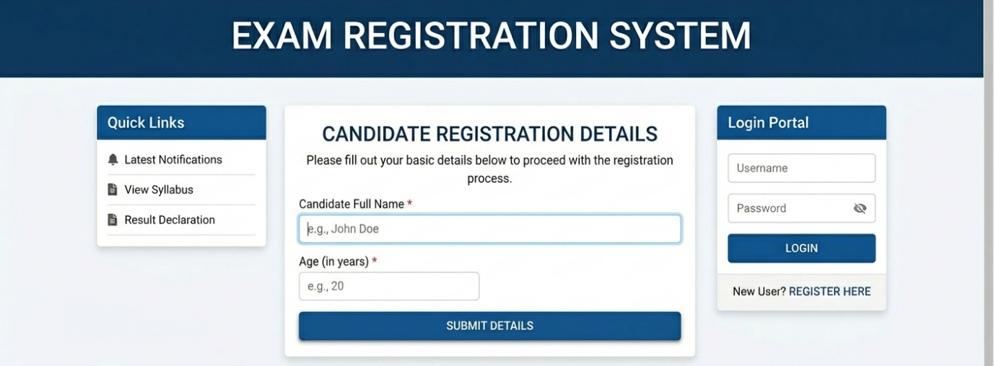

RESULT:
A Servlet is created to process the HTML form data and display it back on the browser.

